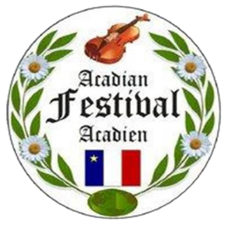

2022 Annual Acadian Festival
“Vive les Acadiens”, “Long live the Acadians”
Celebrating “44” Years in Our Community”

Dear business owners, community leaders and potential sponsors,
Enclosed, please find information regarding the 44th Annual Acadian Festival Sponsorship Package. The committee is working diligently to bring new events and entertainment, for young and old alike, to this year’s festival.
The 44th Annual Acadian Festival dates are August 11th- 15th. As one of Maine’s largest cultural festivals, the Acadian Festival celebrates our rich Acadian heritage and draws thousands of visitors to the St. John Valley area each year. We believe this will be one of the best events this year.
The festival will have a wide variety of activities such as the Tintamarre parade, Party Du Main Street, human foosball, an exciting Family Fun Day and entertainment including performances by “The LeBlanc Family”, celebration of our culture, Treasures of the Valley and our annual parade, delicious food and much more! You will not want to miss being a part of this exciting and growing community event!
We are currently seeking sponsorship support from all our local businesses, leaders and major corporate sponsors. Traditionally, our local businesses have been very generous, involved, and supportive of this annual festival. Our goal is to make this an exciting and fun filled festival that will draw thousands of family members and visitors to the Greater Madawaska area.
The enclosed sponsorship levels identify the benefit package that your company or organization will receive by supporting this huge community event. Remember that in sponsoring this year’s event, your business will be included in our event schedule with many more benefits! Please fill and mail the completed sponsorship confirmation form along with your advertising logo & specifications with a check payable to Acadian Festival Committee, 328 St. Thomas Street, Suite 101, Madawaska, ME, 04756.
For additional information, please visit our website at www.acadianfestival.com. On behalf of the planning committee, we thank you for your time and consideration.

Jane Carter, Chair
2022 Madawaska Acadian Festival Committee

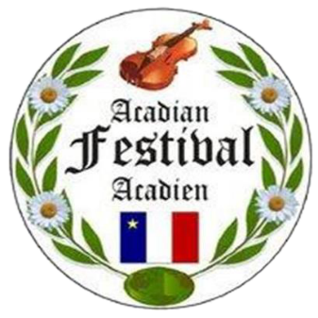

44th Annual
Madawaska Acadian Festival
Maine’s Largest Cultural Event

August 11th - 15th, 2022

www.acadianfestival.com

Sponsorship
categories are as follows:

Platinum – Gold – Silver – Bronze
Patron & Individual
(described attached)

Our theme is:

“Vive les Acadiens”
(Long live the Acadians)

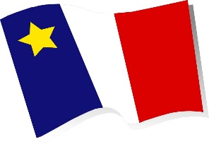

Sponsorship Guideline

The Acadian Festival offers several levels of Sponsorship packages as described below:

Platinum – $2500
Platinum sponsors will receive three days of mentions from the Opening/Welcoming Ceremony to the Closing.
Mentions throughout the weekend during all the events.
Posters and banners distributed throughout the weekend.
Mentioned in all Media such as the Acadian Festival Brochure, Television, Radio and Print as a Major Sponsor. (All media)
Posted on our website as a Major Sponsor.
Front Cover of Brochure.

Gold - $1500
Gold sponsors will receive mentions during the Opening/Welcoming Ceremony to the Closing.
Mentions for event that is sponsored during the weekend.
Posters and banners distributed throughout the weekend for specific event sponsored.
Mentioned in all Media such as the Acadian Festival Brochure, Radio and local print as a Gold Sponsor and posted on our website.

Silver - $1000
Silver sponsors will receive mentions during the Opening/Welcoming Ceremony.
Mentions for event that is sponsored during the weekend.
Banners distributed throughout the weekend for the special event applied.
Mentioned in Media such as the Acadian Festival Brochure and local print as a Silver Sponsor and posted on our website.

Bronze - $500
Bronze sponsor will receive mentions in the following:
Mentions for event that is sponsored during the weekend.
Banners distributed throughout the weekend for the special event applied.
Mentioned in Media such as the Acadian Festival Brochure and local print as a Bronze Sponsor and posted on our website.

Patron Sponsor - $250
Patron sponsor will receive mentions in the following:
Mentioned in Media such as the Acadian Festival Brochure and local print as a Patron Sponsor and posted on our website and Facebook.

Individual Sponsor - $100
Individual sponsor will receive mentions in the following:
Brochure and local print as a Sponsor

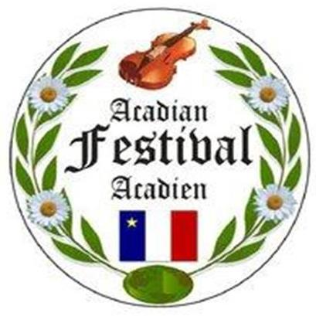
Sponsorship/ Donation Agreement
Sponsor Copy
I / We __________________________________ Agreed upon this day _____________, to act as sponsor to the 2022 Acadian Festival in the amount of $____________, as a
_____________ Sponsor.
Payable by check # _________ and dated on this day, ________________. The sponsorship money generated will help promote the Madawaska Acadian Festival on August 11, 12, 13, 14 and 15th, of 2022.
I / We understand and agree that the funds being committed will be paid to the order of the Madawaska Acadian Festival Committee. Please Note: In order to guarantee your placement of Logos and business name in the media and brochures, we must receive your sponsorship before the deadline of April 30th, 2022. Any sponsorships received after this date, will not be guaranteed to appear in the media or brochures.

______________________________________________________________________
Sponsor Signature Date

Please make check payable to the “Acadian Festival”
Mail to:
Acadian Festival Committee
328 St Thomas Street, Suite 101
Madawaska, Maine 04756

Please keep this copy as receipt or proof of your generous sponsorship. We, the 2022 Madawaska Acadian Festival Committee would like to sincerely thank you for your time and consideration.

Jane Carter, Chair
2022 Madawaska Acadian Festival Committee

Sponsorship/ Donation Agreement
Committee Copy
I / We __________________________________ Agreed upon this day _____________, to act as sponsor to the 2022 Acadian Festival in the amount of $____________, as a
_____________ Sponsor.
Payable by check # _________ and dated on this day, ________________. The sponsorship money generated will help promote the Madawaska Acadian Festival on August 11, 12, 13, 14 and 15th, of 2022.
I / We understand and agree that the funds being committed will be paid to the order of the Madawaska Acadian Festival Committee. Please Note: In order to guarantee your placement of Logos and business name in the media and brochures, we must receive your sponsorship before the deadline of April 30th, 2022. Any sponsorships received after this date, will not be guaranteed to appear in the media or brochures.

___________________________________________________________________
Sponsor Signature Date

Please make check payable to the “Acadian Festival”
Mail to:
Acadian Festival Committee
328 St Thomas Street, Suite 101
Madawaska, Maine 04756

Committee receipt or proof of your generous sponsorship. We, the 2022 Madawaska Acadian Festival Committee would like to sincerely thank you for your time and consideration.
Jane Carter, Chair
2022 Madawaska Acadian Festival Committee

