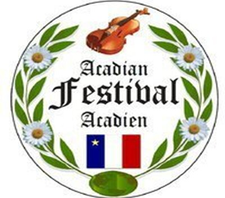

Madawaska Acadian Festival Committee

328 St. Thomas Street, Suite 101

Madawaska, Maine 04756

Tel: 207 728-6250

Fax: 207 728-3611

The 44th Annual Acadian Festival will soon be around the corner. The Festival Committee has put in many hours to make this year another memorable one for the festival. The festival parade is the culmination of a busy, enjoyable week, a sort of icing on the cake. Since last year’s parade was a success, the committee is looking forward to topping it.

We hope you will accept our invitation to put an entry or walk in this year’s parade. Since this event brings in thousands of people from near and far, this will be a great opportunity to represent your business or organization. In 2022 we have added CASH PRIZES for parade entries in certain categories!

Enclosed you will find an entry form to fill out and send to our parade organizers, Jane Carter and Theresa Theriault. You can also contact Jane by calling her at 207-728-6250 or by faxing using the above mentioned number, making sure to put on your cover letter.

ATTN: ACADIAN FESTIVAL COMMITTEE

We look forward to an entry from your business organization. Let’s make the 2022 parade bigger and better than ever!

Sincerely,

Acadian Festival Committee

Jane Carter & Theresa Theriault

Parade Organizers

**44th Annual Acadian Festival Parade Entry Form**

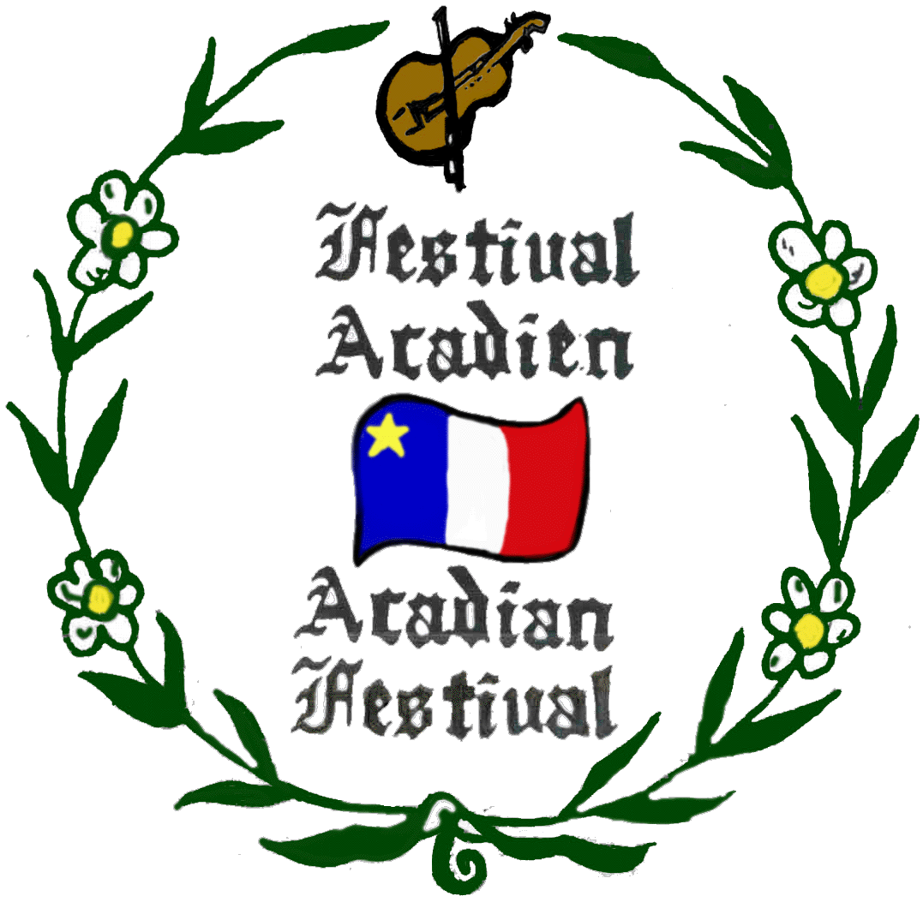

**Acadian Festival Parade**

**August 14th, 2022 at 1pm**

**Rain or Shine**

**Line up at 12:00pm - Fox Street**

Name of Group or Business: _______________________________________________

Address: _______________________________________________________________

Telephone: _____________________________________________________________

Contact Person: _________________________________________________________

Email Address __________________________________________________________

We will enter the following type of unit in the parade: __________________________

Does your entry have any form of music: _____________________________________

**Cash prizes will be awarded in the following categories and will be given out at the**

**Multi-Purpose Building on 7th Ave after the parade.**

1. Best Acadian Theme $100! 2. Best Non-Profit $100!          3. Most Original $100!

4. Most Entertaining $100! 5. Best Business Float $100!

There will be no throwing of candy or anything else from the floats, as this may cause a hazard for children.  Please have someone walk besides the float to hand out candies or whatever you are handing out.  This will ensure safety for everyone.  We thank you for your help in this matter.

Please make sure entry is in no later than August 1, 2022

Send entry form to: Acadian Festival Committee

           328 St. Thomas Street, Suite 101

        Madawaska, Me 04756